Research / Communication Strategy
Project Partner Name

Table of Contents

EXECUTIVE SUMMARY – POSTER FORMAT ii
1 INTRODUCTION 1
2 THE STRATEGY 1
2.1 Audiences & stakeholders 1
2.2 Methods and media combinations 1
2.3 Purposes and audiences 2
2.4 Communication objectives 2
3 STEPS FOLLOWED IN THE DESIGN PROCESS 2
4 IMPLEMENTATION 4
4.1 Capacity development 5
4.2 The RAPID framework 5
4.3 Monitoring & evaluation 6
4.4 Conclusions 7
5 APPENDICES 7
5.1 Theory of Change 7
5.2 Audience research findings 8

Figures

Figure 1: Five communication design steps 3
Figure 2: The steps leading to communication design 3
Figure 3: The steps for communication design, implementation and M&E 4
Figure 4. The RAPID Framework (ODI) 5
Figure 5. Conceptual framework for M&E (John Hopkins, 2006; In: Sullivan et al., 2007: 4) 6

EXECUTIVE SUMMARY – POSTER FORMAT
[Project Name] Communication Strategy

Communication Purposes

Stakeholders & Audiences

Methods & Media

Outcome Metrics
Communication objectives

INTRODUCTION

The Research / Communication Strategy sets forth a coherent set of purposes and objectives. This strategy was developed starting with a systematic review of existing practices to ensure continuity. It included an audience research phase to verify stakeholders’ existing knowledge and information needs, as well as preferred media channels and products. The strategy is designed to serve as a decision-making guide for everyday communication activities. It is also a reflection piece to ensure that future communication efforts can be monitored and improved.

The strategy follows the following principles:

- Start with where the organization is at this moment (by pausing, reflecting and naming what is already being done)
- Clarify purposes – the what
- Identify key audiences/stakeholders – the who
- Assess best avenues for communication with each type of stakeholder – the how
- Select methods and media (to match both purpose and audience)
- Build capacity among the team members
- Field test communication products
- Implement with a realistic M&E plan (and seek to overlap with any Key Evaluation Questions associated with the Communication Strategy

THE STRATEGY

This strategy is composed of X PURPOSES that underpin the communication work of the Project Team. The Communication Objectives that are the main drivers of the strategy appear associated with each purpose.

Audiences & stakeholders

Methods and media combinations
The following are not listed in any order of priority:

Purposes and audiences
There is a correspondence between purposes and the audience and stakeholder groups:

Purpose | Audience/stakeholder

Communication objectives

Unpacking purposes and objectives [if more narrative is needed]

STEPS FOLLOWED IN THE DESIGN PROCESS

Figure 1 summarizes the first five steps in the design process. The notion of readiness is central to the DECI-2 approach. This idea refers to the extent to which the team is committed to the planning and implementation of a Communication Strategy. Situational analysis addresses the internal context (existing activities, organizational separation of duties, organizational culture, and internal relations), as well as the external environment (relations of trust, global policy).

[Add relevant details as needed.]
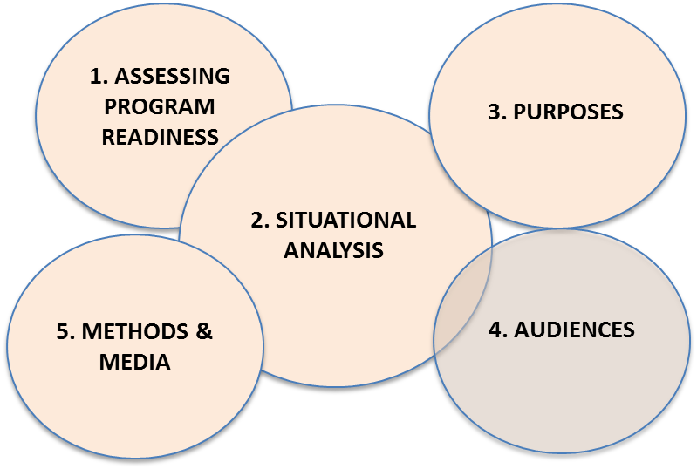
Figure 1: Five communication design steps

The fact that Audience Research contributes to Situational Analysis underlines that the planning steps are iterative, rather than linear.

[Add relevant details as needed.]

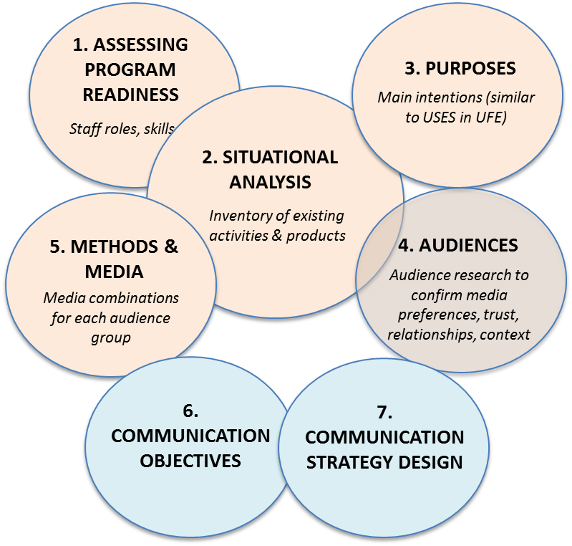
Figure 2: The steps leading to communication design

[Add relevant details as needed, especially on the process of formulating the Communication Objectives]

The communication objectives represent the strategic and measurable statements that guide the design of the Communication Strategy.

IMPLEMENTATION

While this document specifies the CS Design (Step 7), much remains on the drawing board. This work includes: the pretesting of communication materials, the implementation of the Communication Objectives, and the monitoring & evaluation activities. Step 11 (institutionalization) refers to the reflection process that is recommended at the end of the program cycle to harvest lessons learned and adjust them to future plans.
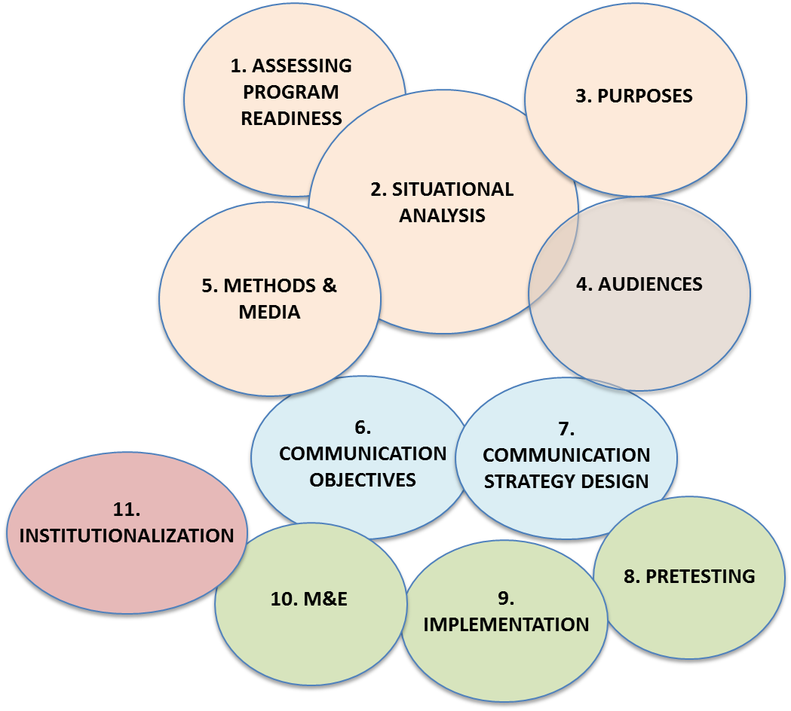
Figure 3: The steps for communication design, implementation and M&E

Effective implementation of a CS requires:
- The capacity and operational plan (skilled staff);
- An understanding of how the strategy fits with the everyday work that staff are already implementing (communication objectives embedded in work plans);
- An M&E plan (with a realistic data collection plan); and
- A time line and a budget.

Capacity development

“Internal capacity for research uptake includes the knowledge, skills and attitudes needed to access, use, create and communicate research information.”

The DECI-2 project is the main vehicle through which research communication and evaluation capacity development is taking place with partners. From the steps already covered, the skills required include within the project include: [Add relevant details as needed.]

- Project management skills to schedule, implement, and monitor communication activities and products
- Writing in a clear, concise style for non-technical audiences
- Timing different channels, products and media activities, such as Twitter feeds to announce the release of relevant items on websites
- Designing conference events and presentations in line with the communication objectives
- Research uptake guidelines often emphasize the principles mentioned in the Introduction. The implementation of the CS will work as a means of internal capacity development for the I&N team. Strategic communication becomes a way of thinking. For instance, pretesting communication materials before production to ensure relevance and suitability, becomes second nature.
- This process also applies to building the capacity of policy makers, build relationships, and help them gain the knowledge and skills to seek evidence from research.
- As additional specialized technologies and applications emerge (e.g. crowd sourcing, social media), the project team may welcome capacity development events that could be shared with partners at conferences.

The RAPID framework
Figure 4. The RAPID Framework (ODI)

The ODI RAPID (Research and Policy in Development) used by DECI-2 as a touchstone of the factors that enable research to influence policy. The framework underlines the importance of: understanding the policy-making context; packaging evidence; networking strategically; and seeking windows of opportunity in the policy environment.

The four RAPID components interact as a system and allow a research team to be ready to take advantage of moments and circumstances when policy makers are open to research inputs. An important principle that the framework conveys is the notion that the research to policy process is part art, part science and part technique. This knowledge in turn has connotations for monitoring and evaluation.

Monitoring & evaluation
UKAid’s Research Uptake guidelines propose outcome categories that “…can include changes to policy or practice, changes to conceptual understanding, changes in behaviour or attitudes and so on.” The guidelines underline the importance of tracking actual outcomes and verifying to what extent they reflect the program’s assumptions and theory of change. This CS takes heed of this advice and focuses on tracking a gradient of outputs and outcomes, for the selection of the Communication Objectives listed in Section 2.
Also of relevance is a conceptual framework for monitoring and evaluating information products and services (Figure 5). It signals “reach” as an output that can be tracked when it is important to verify to what extent a dissemination effort touched different audiences. It goes on to suggest a gradient of “initial outcomes” that include each audience’s appreciation of a product’s usefulness or quality. It then suggests a number of contextual outcomes, such as ‘training & education enhanced’. As with the UKAid’s guidelines, this framework underscores the fact that higher-level outcomes or impacts tend to be difficult, if not impossible, to attribute to the communication outputs.
Figure 5. Conceptual framework for M&E (John Hopkins, 2006; In: Sullivan et al., 2007: 4)

The following is a selection of the Communication Objectives and relevant metrics to track.

Communication Objective | Output | Outcome

The list of outcomes and outputs, once confirmed, will be the foundation of the M&E plan. The plan will: a) confirm qualitative and quantitative indicators to track [once we have these we can update the Metrics box in the POSTER], b) produce data collection instruments to collect the relevant indicators, and c) assign staff responsible to file, analyze, and report the indicators.

Conclusions
This Communication Strategy (CS) signals that the I&N program works on three elements; and from that structure there are eight purposes (Section 2.3) and twelve communication objectives. As emphasized above, the CS serves as a decision-making guide to help the I&N team focus energies on the most effective ways of communicating. Below we summarize the type of challenges that emerged during the two design workshops, and we align them with the respective purposes. Not all have relevant answers at this stage, but there is now a mechanism to address them in a concerted manner.

Purpose | Challenge

APPENDICES

Theory of Change

Audience research findings

Methods and Media | Partner feedback

UKAid, 2013. Research uptake: A guide for DFID-funded research programs. London: UKAid (p.6)
Bernard et al, op.cit. (p.12)
Sullivan, T.M.; Strachan, M. & Timmons, B.K. 2007. Guide to monitoring and evaluating health information products and services. Washington: USAID.

